**UJJAWAL WORKSPACE OF IBM CLOUD**

**-19BIT0072**

**VIT VELLORE**

**Challengers.csv space shuttle usecase :-**

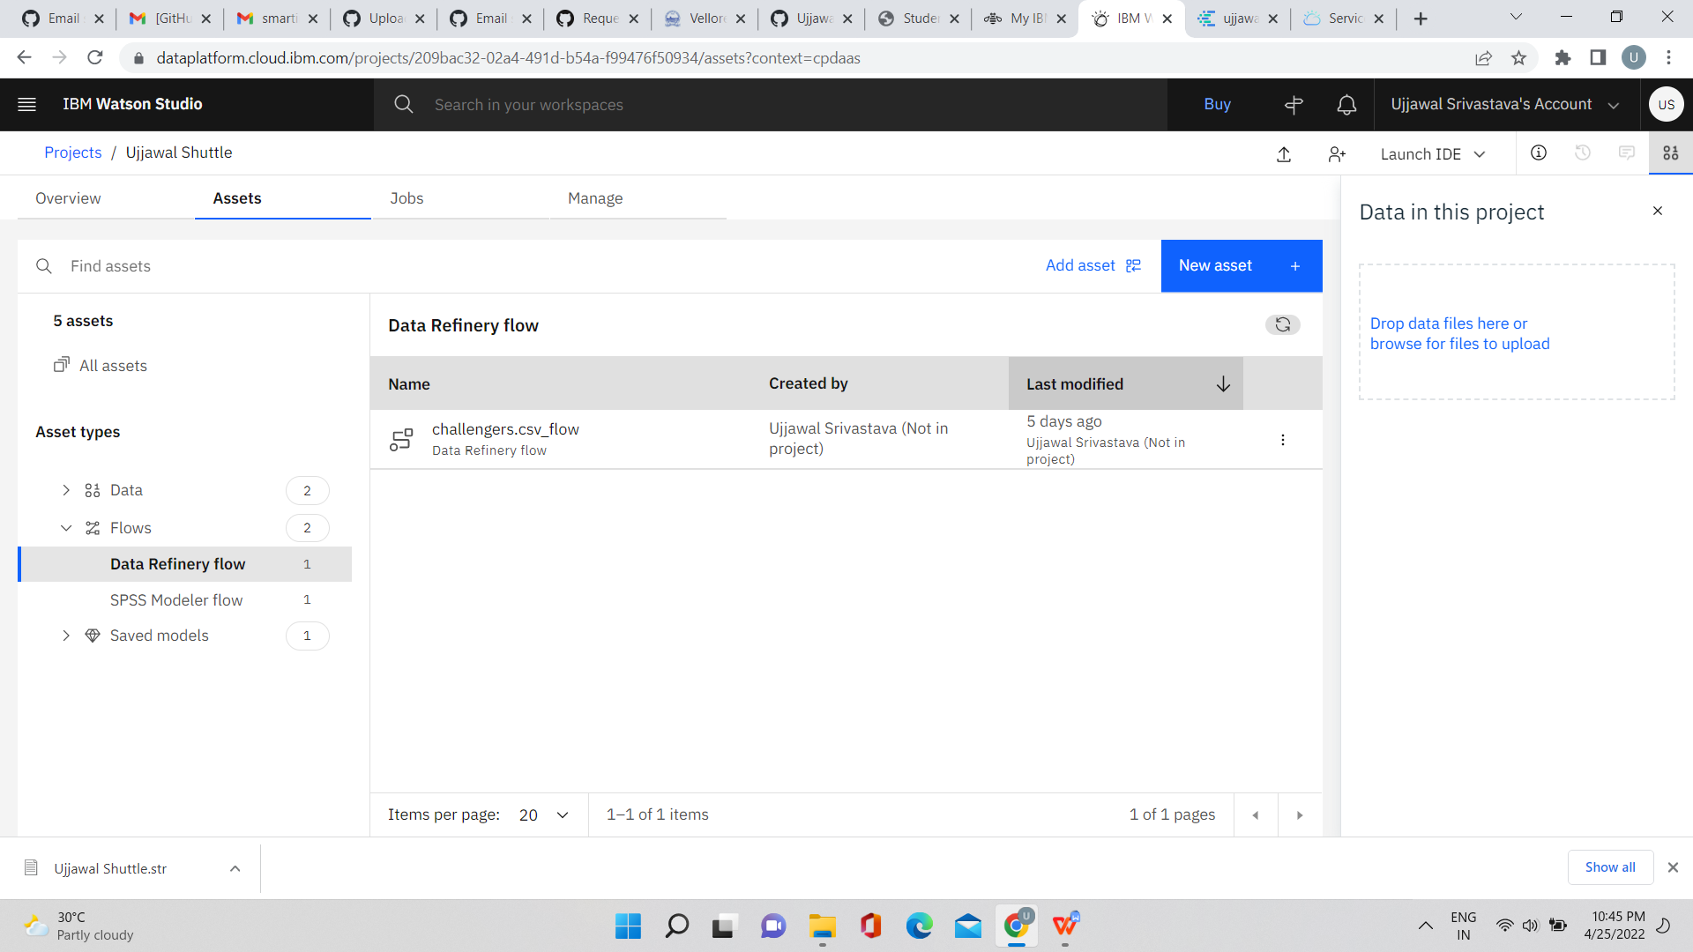

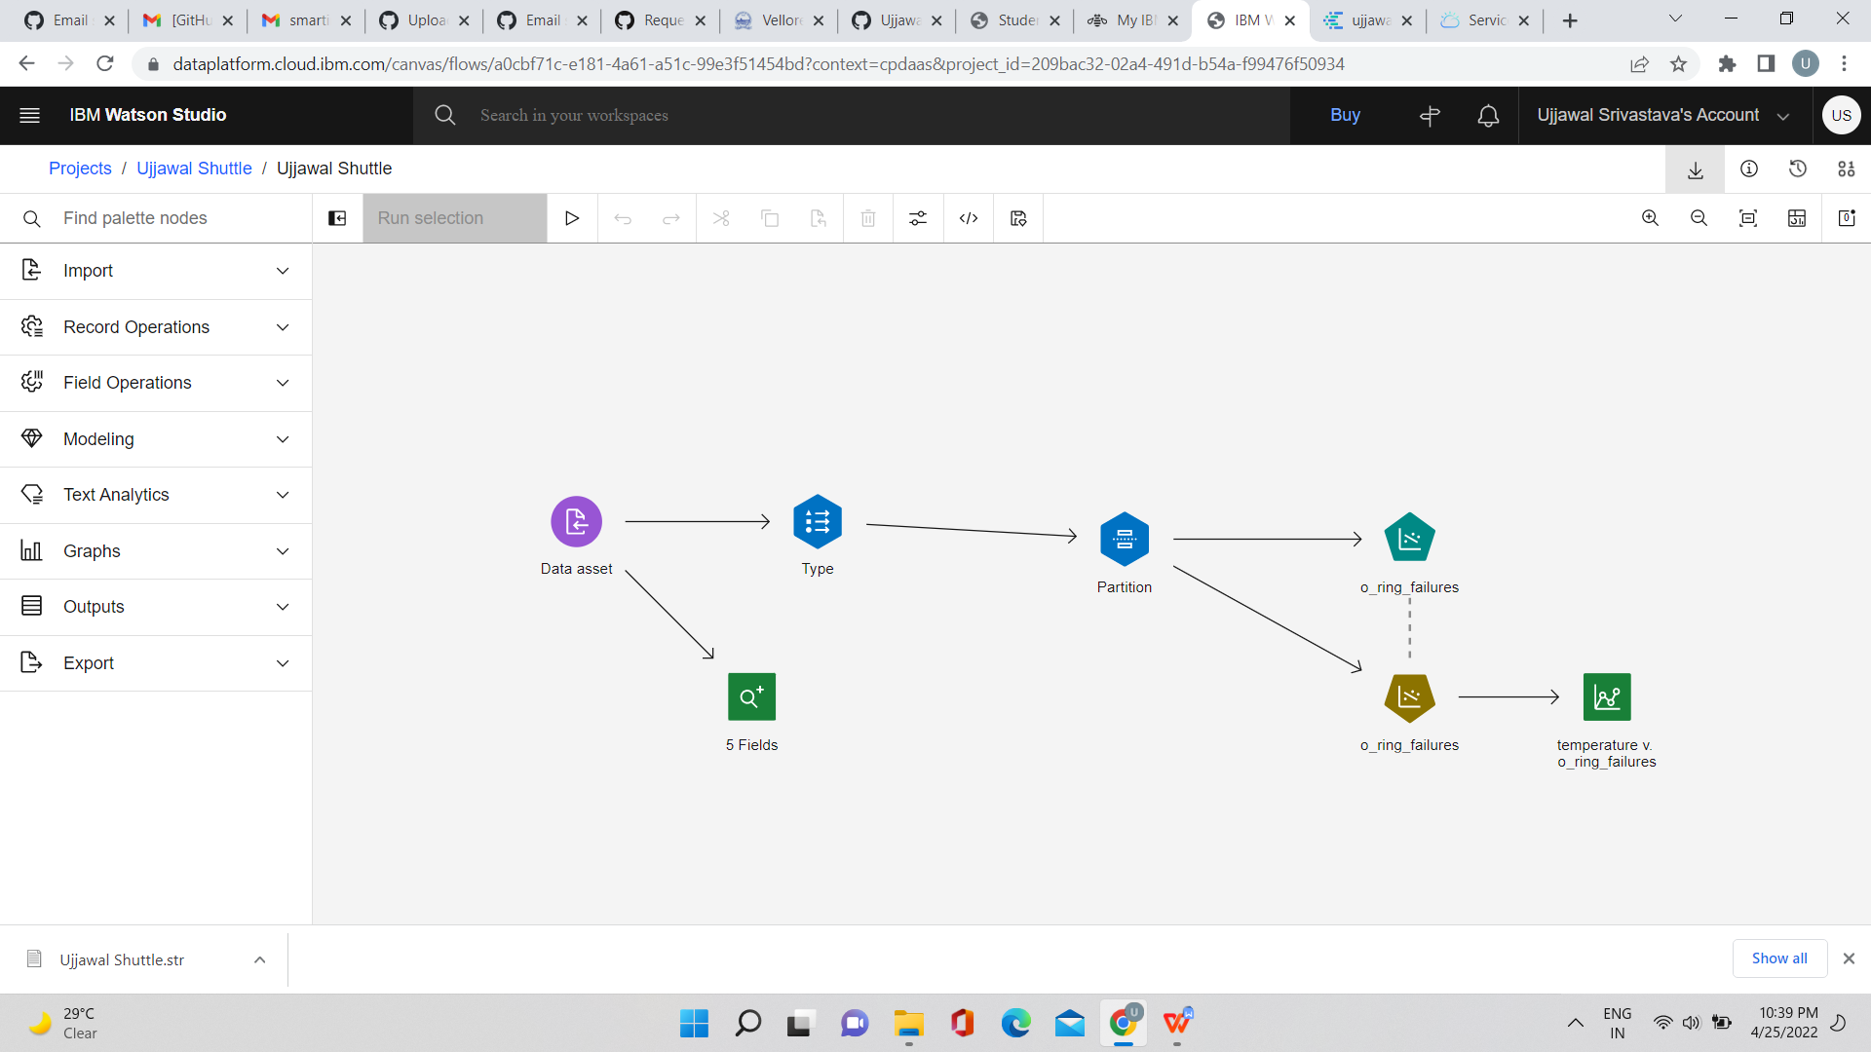

Diabetes.csv diabetes patient use case study:

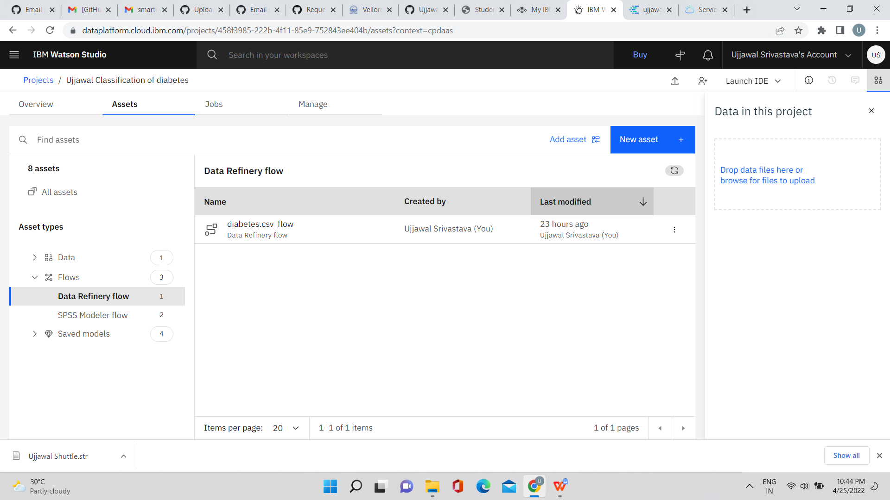

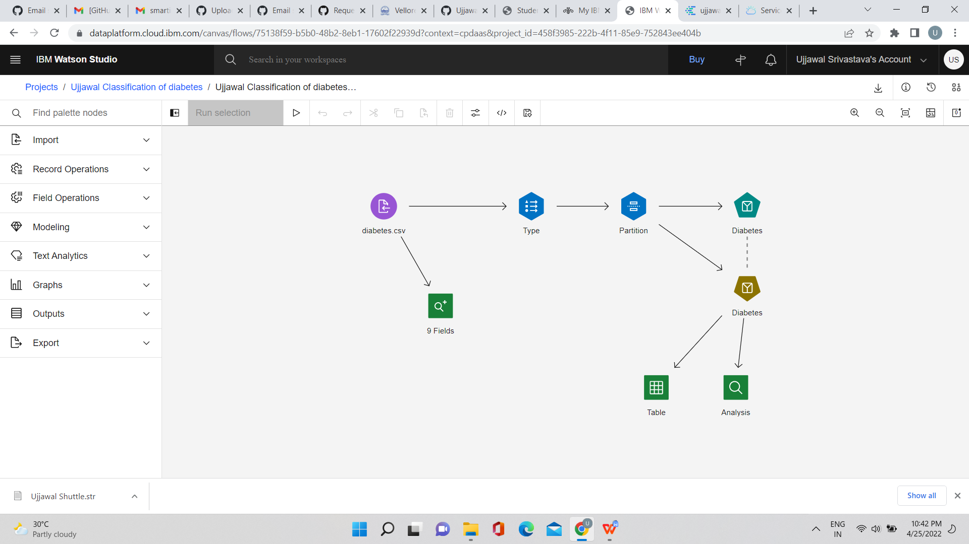

Mall customers use case :-

